

Mr. Bedard’s Blog

Read for The Record!

Cell Phones Use

As part of our community service goal, the Peabody Learning Academy shared the importance of literacy and learning when we participated in Read for the Record, a nation wide event on October 4th, 2012, that is considered to be the country’s largest single-day reading experience.

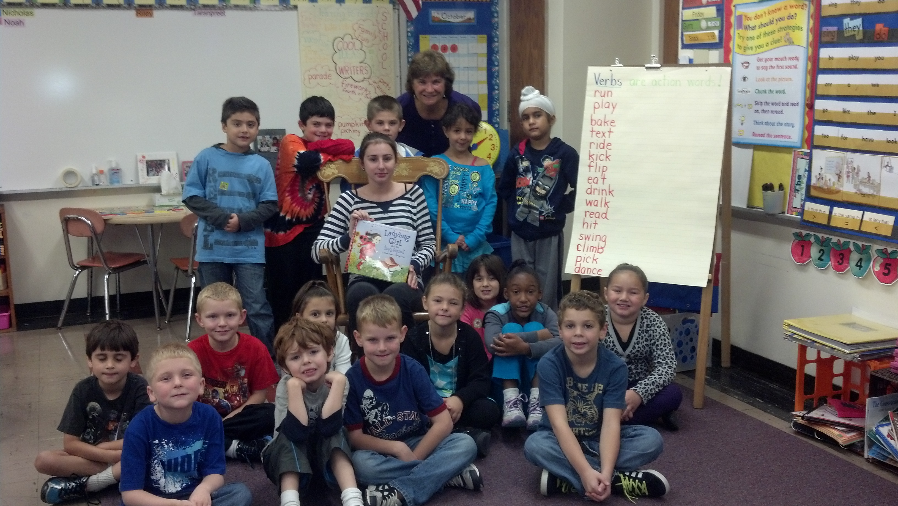

One of Read for the Record’s sponsors, the Pearson Foundation, provided 30 copies of the book Ladybug Girl and the Bug Squad, the book selected for this year’s program, to the students of The Peabody Learning Academy. The Academy students took their book copies into each of the 1st and 2ndr grade classrooms in the city of Peabody and read for the children in those classes. After reading Ladybug Girl and the Bug Squad, the Academy students donated
the copy of the book to the class. Our students understand the importance of education. I am very proud that they wanted to share their passion for learning with a younger generation here in their home town. It was a wonderful experience and very rewarding for all of the students involved.

Some students are having difficulty managing their cell phone use in school. The rule is simple: Cell phones are not permitted at PVMHS or the Peabody learning Academy. That means that before or after school is fine. However, during school cell phone use is not allowed. Why? If a student needs to be contacted in an emergency, notification can be facilitated through Mr. Bedard’s office (978) 536-5575. Other than that, student personal calls should be delayed until after school. Cell phones are a distraction in class and take away from important class time. The rule applies even when a substitute teacher is covering the class. Cell phone etiquette is important to learn. In professional meetings, participants are expected to turn their phone off and keep them off during the meeting.

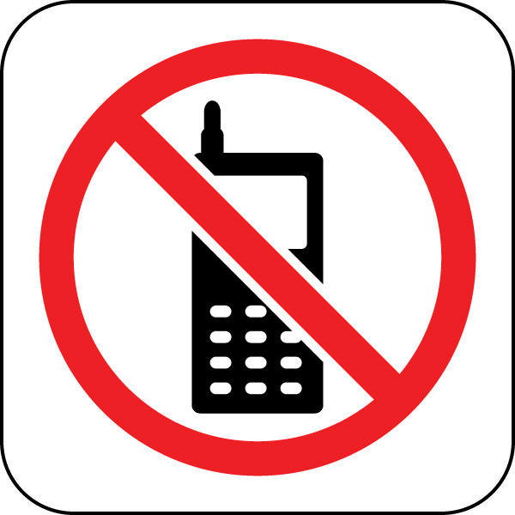

Who are the culprits? Other distracted students and believe it or not, parents are guilty of violating the rule. I understand that situations arise and you may need to contact your child. However, we are trying to complete years worth of school work in a very short time. Every second counts! Let’s work together to get this under control. Please revisit the student handbook and read the Cell Phone Use Policy.

Peabody Learning Academy
Peabody, MA

October 1, 2012
Volume 3, Issue 2

October 2 Early Release

October 4 Read for the Record Trip

October 8 Columbus Day – No School

October 10 Class of 2013 picture

October 11 AP SCIENCE PREP (PVMHS)

October 17 PSAT for grade 10

October 20 Picture day

October 25 Halloween Dance

Mr. Bedard’s News Letter

The following students have passes the following classes and received 5 CREDITS TOWARDS GRADUATION!!!!

Rebecca Conant Sociology
Shantel Ramos Astronomy
Peter Witwicki English 12
Brianda Burgos World History
Giuliana Staff Chemistry
Kayla Wagar Biology
Corrina Samayoa Environmental Science

October Highlights

The Peabody Learning Academy now on the Web. Check us out at http://peabodylearningacademy.com/

